Name: Cameron Glynn

Student ID: 99228504

DTEC502 Final Practical Test Answers

# Q1.

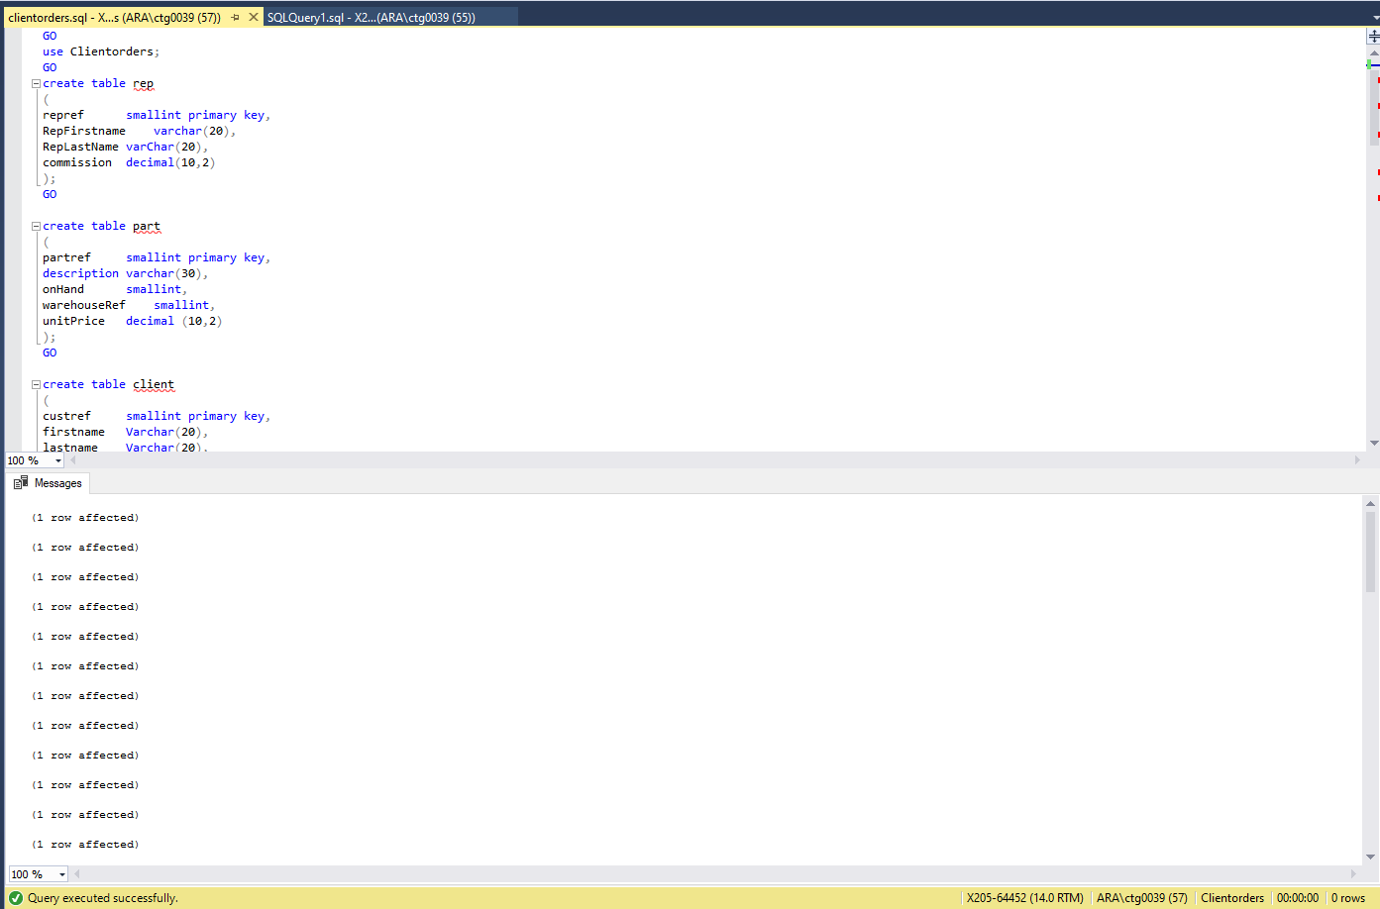

# Q2.

SELECT [firstname],[lastname],[city] FROM [dbo].[client]

WHERE [city] = 'Dunedin'

GO

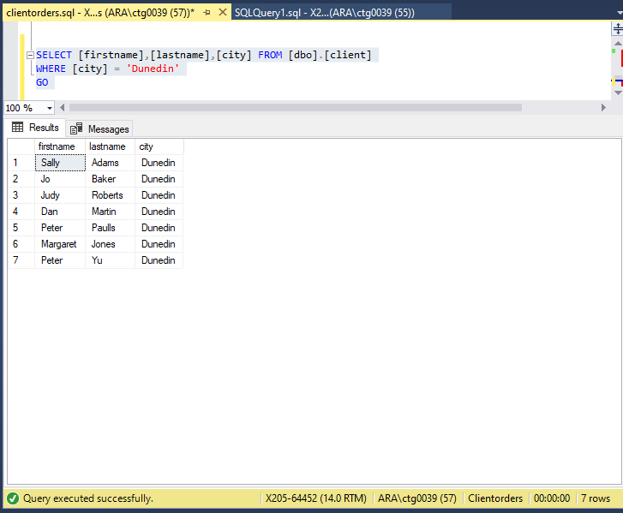

# Q3.

SELECT [firstname],[lastname] FROM [dbo].[client]

WHERE [lastname] LIKE 'J%'

GO

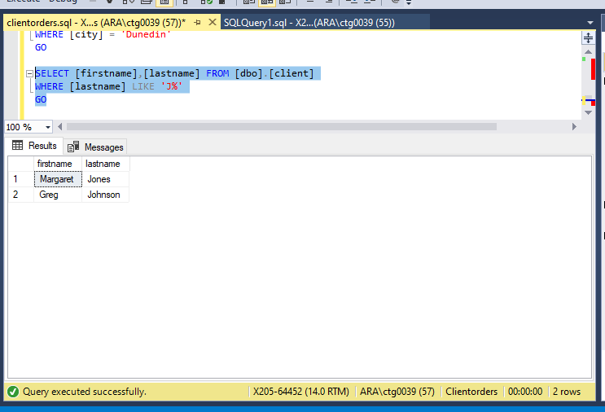

# Q4.

SELECT [firstname],[lastname],[balance] FROM [dbo].[client]

WHERE [balance] BETWEEN 50 AND 150

GO

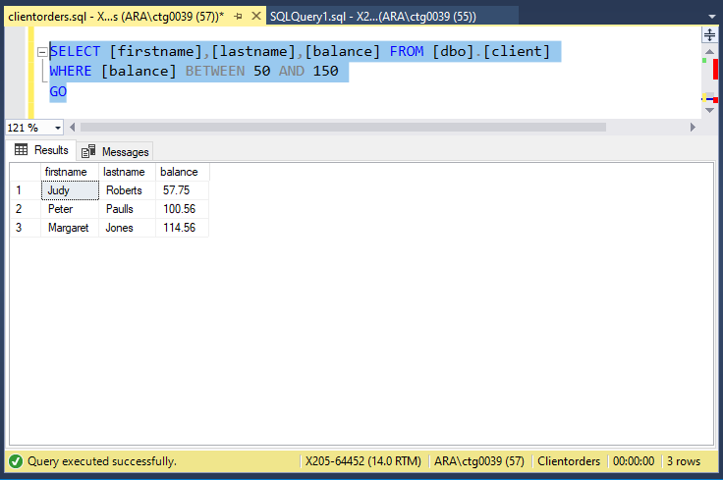

# Q5.

SELECT [firstname],[lastname],[city] FROM [dbo].[client]

WHERE [firstname] = 'Mary' AND [lastname] = 'Nelson'

GO

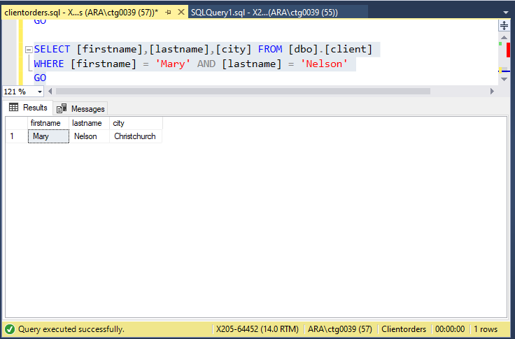

# Q6.

SELECT [firstname],[lastname],[balance], [city] FROM [dbo].[client]

WHERE [balance] < 200 AND [city] = 'Dunedin'

GO

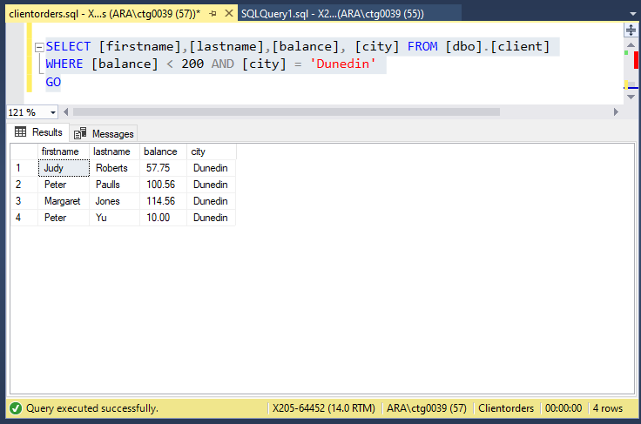

# Q7.

SELECT [custref], [creditlimit], [balance], [creditlimit]-[balance]

AS NewBalance

FROM [dbo].[client]

GO

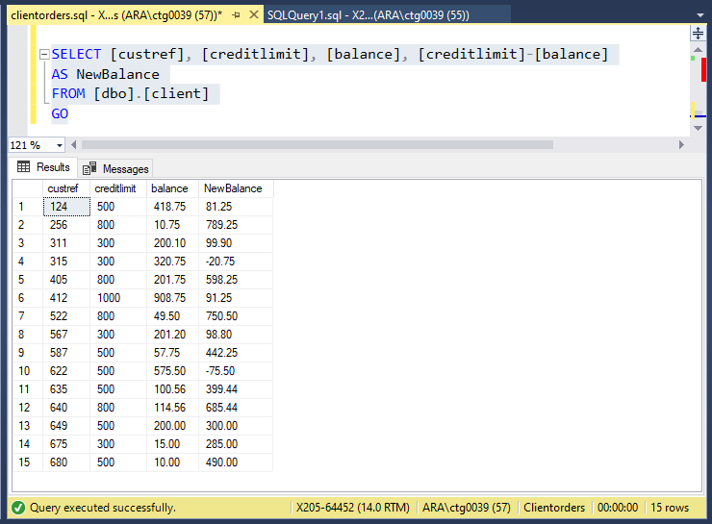

# Q8.

SELECT [orderref], [partref], [quantity], [quotedPrice],

[quantity]*[quotedPrice] AS LineTotal

FROM [dbo].[orderline]

GO

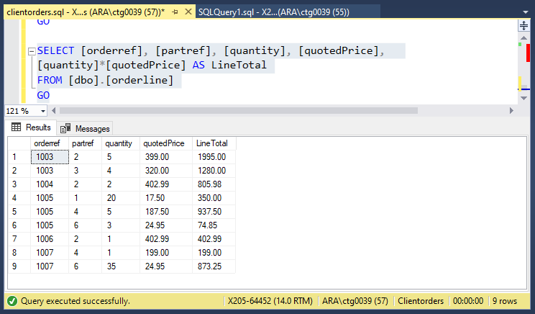

# Q9.

SELECT [orderref],[orderdate]

FROM [dbo].[custorder]

WHERE [orderdate] > '6-1-99'

GO

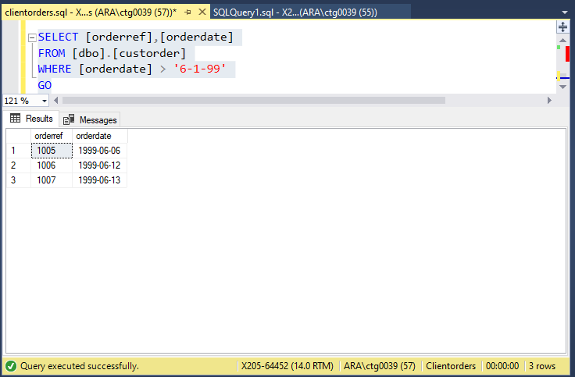

# Q10.

SELECT [city], COUNT([custref]) AS 'Number in each city'

FROM [dbo].[client]

GROUP BY [city]

HAVING COUNT([custref]) > 3

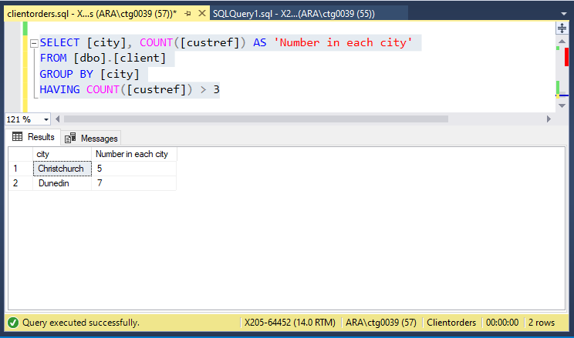

# Q11.

SELECT [dbo].[rep].[repref], SUM([dbo].[client].[balance])

AS 'Total balance'

FROM [dbo].[rep] INNER JOIN [dbo].[client]

ON ([dbo].[rep].[repref] = [dbo].[client].[repref])

GROUP BY [dbo].[rep].[repref]

GO

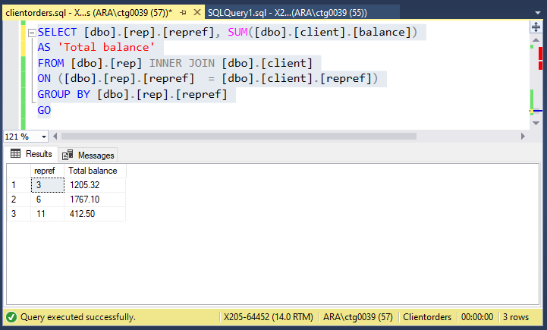

# Q12.

SELECT [city], MAX([balance]) AS 'Max balance'

FROM [dbo].[client]

GROUP BY [city]

GO

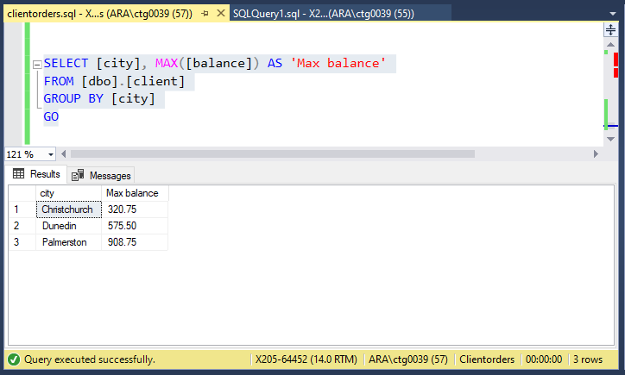

# Q13.

SELECT CONCAT([dbo].[client].[firstname], ' ' , [dbo].[client].[lastname]) AS 'Client name',

CONCAT([dbo].[rep].[RepFirstname], ' ' , [dbo].[rep].[RepLastName]) AS 'Rep name'

FROM [dbo].[client] INNER JOIN [dbo].[rep]

ON ([dbo].[client].repref = [dbo].[rep].repref)

GO

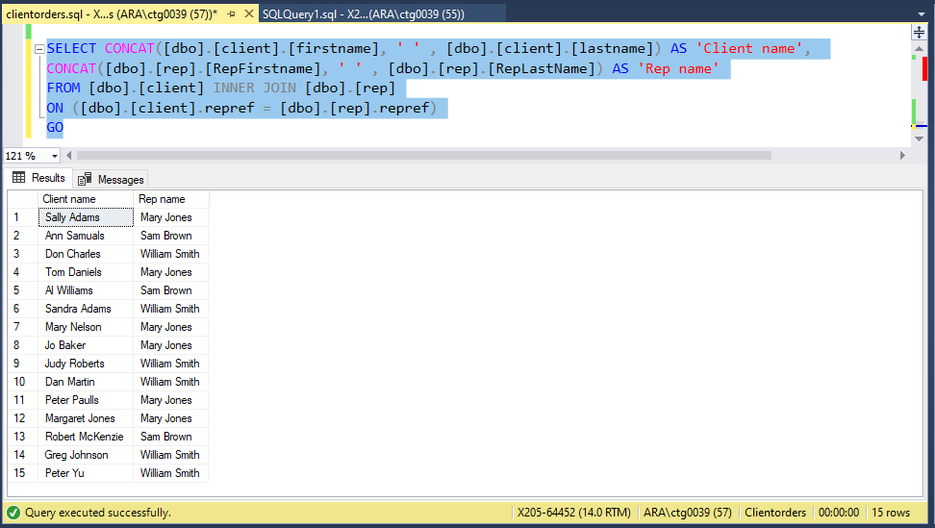

# Q14.

SELECT [orderref], [firstname], [lastname], [orderdate]

FROM [dbo].[client] INNER JOIN [dbo].[custorder]

ON ([dbo].[custorder].custref = [dbo].[client].custref)

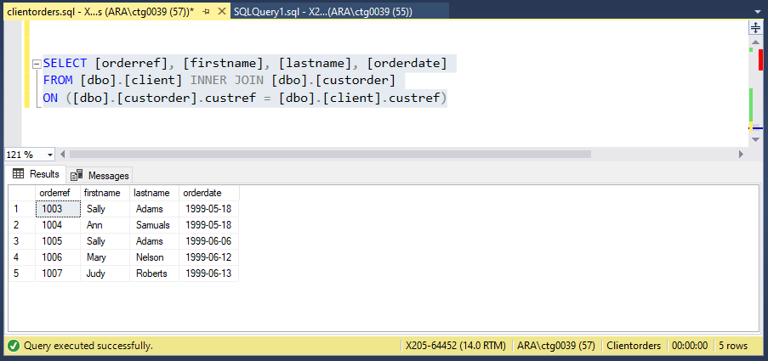

# Q15.

SELECT [dbo].[custorder].[orderref], [description], [onHand]

FROM [dbo].[custorder] INNER JOIN [dbo].[orderline]

ON ([dbo].[custorder].orderref = [dbo].[orderline].orderref) INNER JOIN [dbo].[part]

ON ([dbo].[orderline].partref = [dbo].[part].partref)

WHERE [dbo].[custorder].[orderref] = '1007'

GO

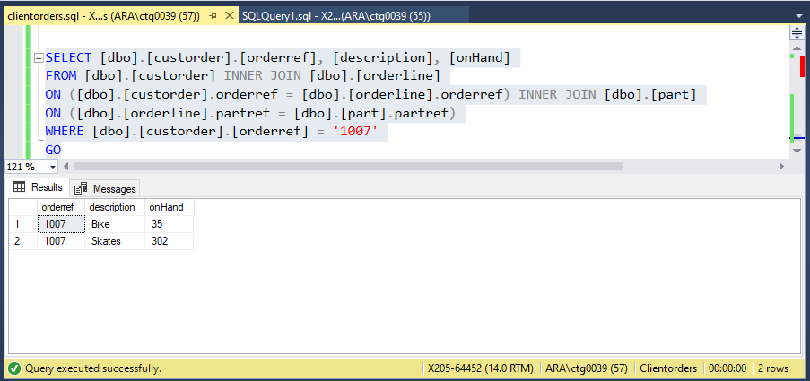

# Q16.

SELECT [dbo].[orderline].orderref, [description], [quotedPrice], [quantity]

FROM [dbo].[orderline] INNER JOIN [dbo].[part]

ON ([dbo].[orderline].partref = [dbo].[part].partref)

ORDER BY [description]

GO

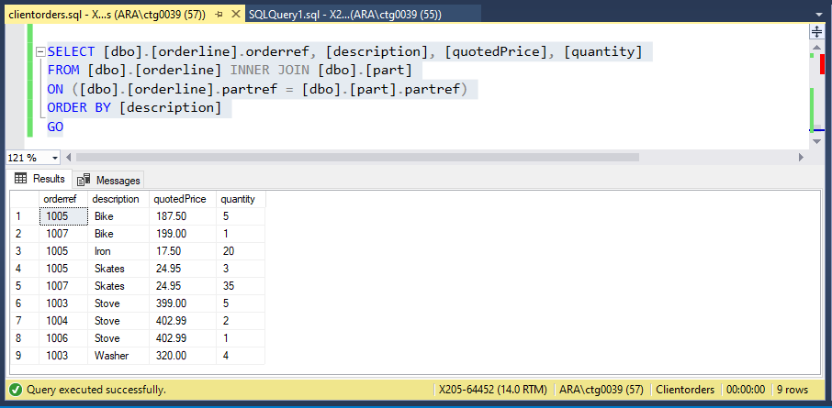

# Q17.

SELECT [dbo].[custorder].orderref, [dbo].[part].description, [dbo].[orderline].quotedPrice,

[dbo].[orderline].quantity

FROM [dbo].[custorder] INNER JOIN [dbo].[orderline]

ON ([dbo].[custorder].orderref = [dbo].[orderline].orderref) INNER JOIN [dbo].[part]

ON ([dbo].[orderline].partref = [dbo].[part].partref)

WHERE [dbo].[orderline].quotedPrice > 200

GO

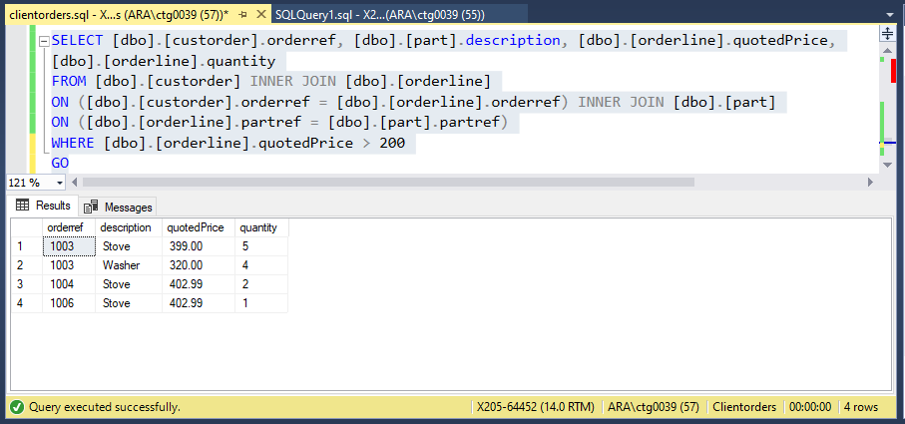

# Q18.

SELECT [dbo].[custorder].[orderref], [orderdate], [firstname], [lastname], [description], [unitPrice]

FROM [dbo].[custorder] INNER JOIN [dbo].[orderline]

ON ([dbo].[custorder].orderref = [dbo].[orderline].orderref) INNER JOIN [dbo].[part]

ON ([dbo].[orderline].partref = [dbo].[part].partref) INNER JOIN [dbo].[client]

ON ([dbo].[client].custref = [dbo].[custorder].custref)

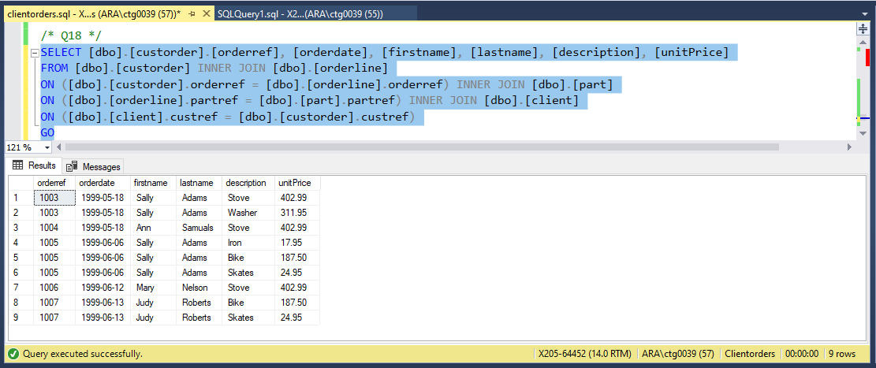

# Q19.

SELECT [dbo].[custorder].[orderref], [orderdate], [firstname], [lastname], [description], [unitPrice]

FROM [dbo].[custorder] INNER JOIN [dbo].[orderline]

ON ([dbo].[custorder].orderref = [dbo].[orderline].orderref) INNER JOIN [dbo].[part]

ON ([dbo].[orderline].partref = [dbo].[part].partref) INNER JOIN [dbo].[client]

ON ([dbo].[client].custref = [dbo].[custorder].custref)

WHERE [orderdate] > '6-10-99'

GO

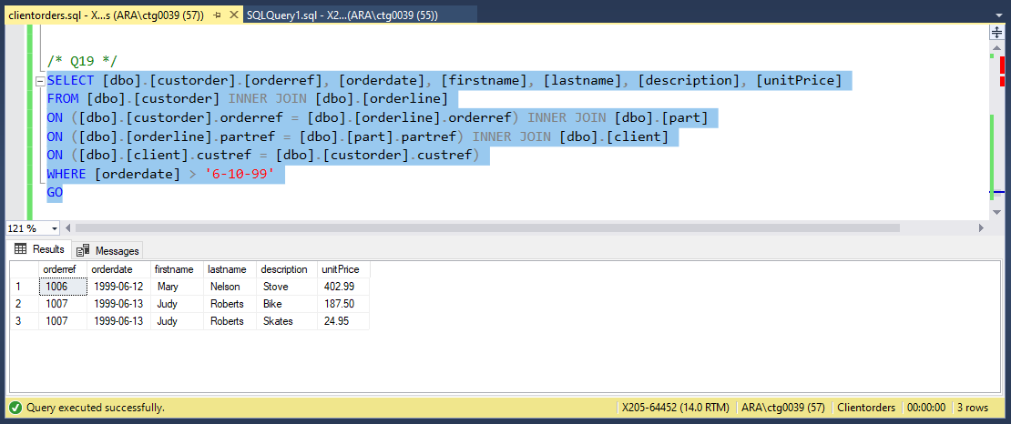

# Q20.

SELECT [dbo].[custorder].[orderref], [orderdate], [firstname], [lastname],[RepFirstname], [RepLastName], [description]

FROM [dbo].[custorder] INNER JOIN [dbo].[orderline]

ON ([dbo].[custorder].orderref = [dbo].[orderline].orderref) INNER JOIN [dbo].[part]

ON ([dbo].[orderline].partref = [dbo].[part].partref) INNER JOIN [dbo].[client]

ON ([dbo].[client].custref = [dbo].[custorder].custref) INNER JOIN [dbo].[rep]

ON ([dbo].[client].repref = [dbo].[rep].repref)

GO

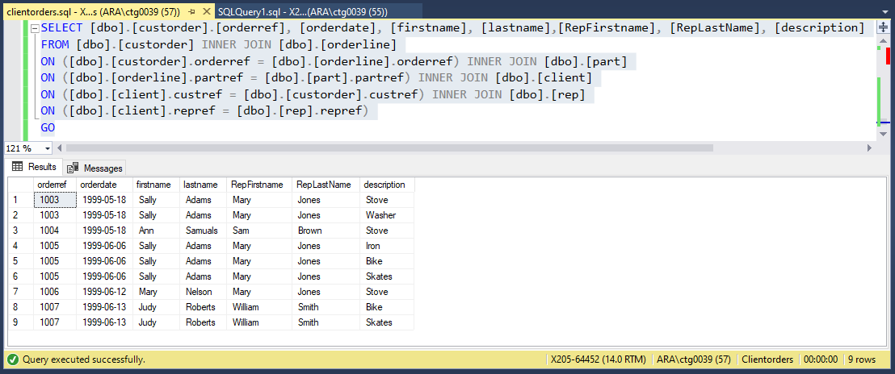

# Q21.

SELECT CONCAT([dbo].[rep].[RepFirstname], ' ' , [dbo].[rep].[RepLastName]) AS 'Rep Name',

SUM([dbo].[client].[balance]) AS 'Total balance'

FROM [dbo].[rep] INNER JOIN [dbo].[client]

ON ([dbo].[rep].[repref] = [dbo].[client].[repref])

GROUP BY [dbo].[rep].[RepFirstname], [dbo].[rep].[RepLastName]

GO

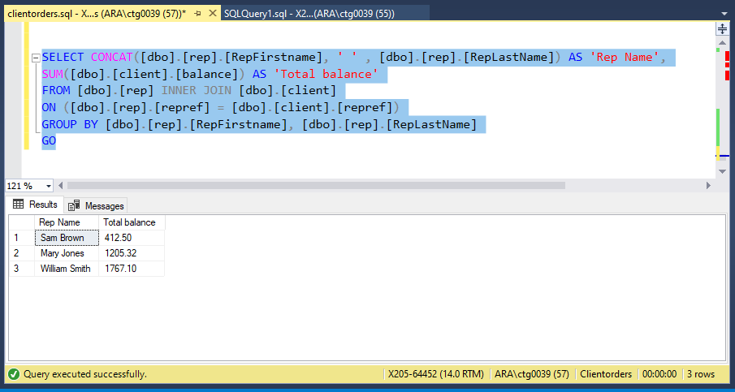

# Q22.

SELECT [orderref], SUM([quantity]*[quotedPrice]) AS 'Total Linetotal'

FROM [dbo].[orderline]

GROUP BY [orderref]

GO

